**“Screenshots”**

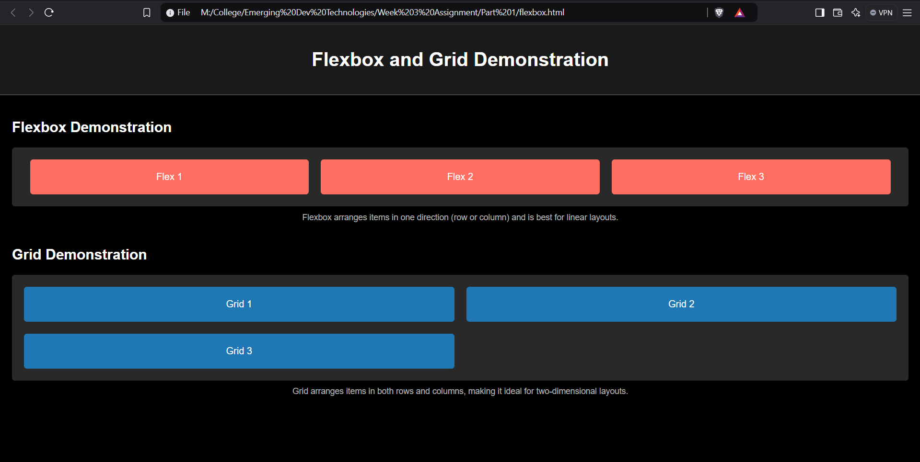

**Flexbox Demonstration:**

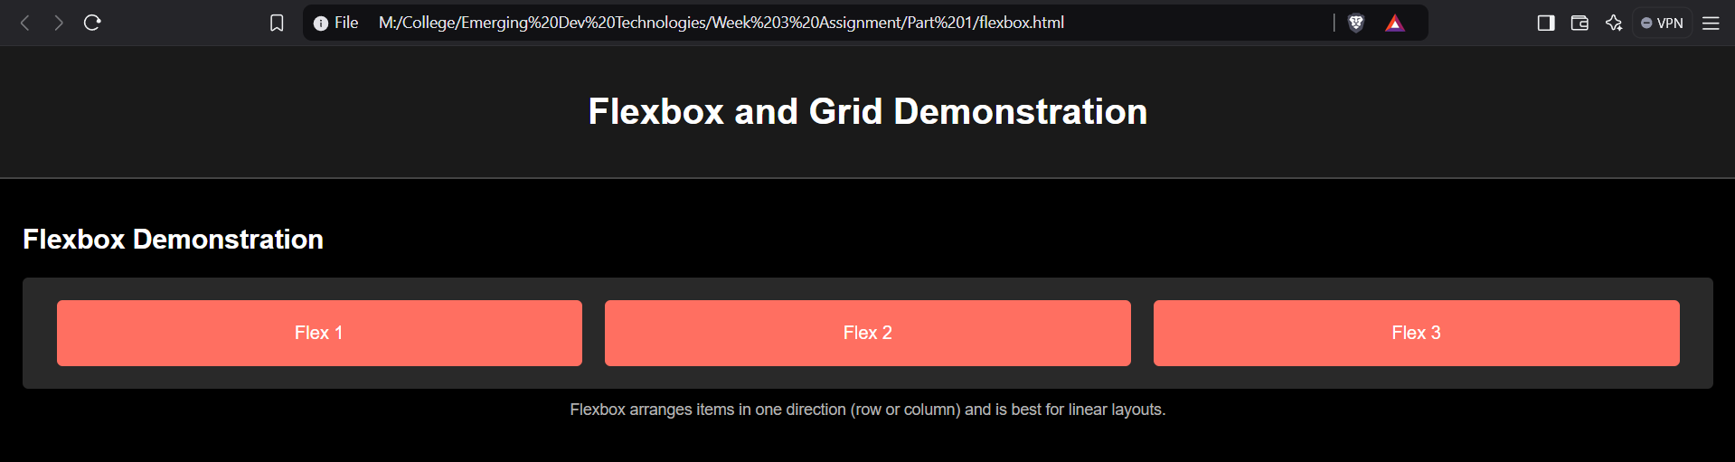

**Grid Demonstration:**

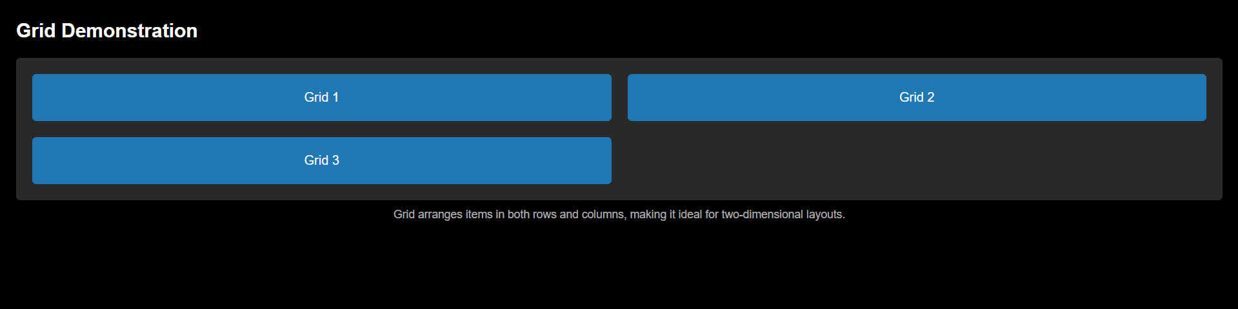

**CODE**:

**HTML CODE:**

<!DOCTYPE html>

<html lang="en">

<head>

<meta charset="UTF-8">

<meta name="viewport" content="width=device-width, initial-scale=1.0">

<title>Flexbox and Grid Demonstration</title>

<link rel="stylesheet" href="flexbox.css">

</head>

<body>

<header>

<h1>Flexbox and Grid Demonstration</h1>

</header>

<main>

<!-- Flexbox Section -->

<section class="flexbox-demo">

<h2>Flexbox Demonstration</h2>

<div class="flex-container">

<div class="flex-item">Flex 1</div>

<div class="flex-item">Flex 2</div>

<div class="flex-item">Flex 3</div>

</div>

<p class="note">Flexbox arranges items in one direction (row or column) and is best for linear layouts.</p>

</section>

<!-- Grid Section -->

<section class="grid-demo">

<h2>Grid Demonstration</h2>

<div class="grid-container">

<div class="grid-item">Grid 1</div>

<div class="grid-item">Grid 2</div>

<div class="grid-item">Grid 3</div>

</div>

<p class="note">Grid arranges items in both rows and columns, making it ideal for two-dimensional layouts.</p>

</section>

</main>

</body>

</html>

**CSS CODE:**

body {

font-family: Arial, sans-serif;

background-color: black;

color: white;

margin: 0;

padding: 0;

}

header {

background-color: #1a1a1a;

text-align: center;

padding: 20px 0;

border-bottom: 2px solid #444;

}

h1, h2 {

margin: 20px 0;

}

main {

padding: 20px;

}

.note {

font-size: 14px;

color: #b3b3b3;

text-align: center;

margin-top: 10px;

}

.flexbox-demo {

margin-bottom: 40px;

}

.flex-container {

display: flex;

justify-content: space-evenly;

align-items: center;

background-color: #292929;

padding: 20px;

border-radius: 5px;

}

.flex-item {

background-color: #ff6f61;

color: white;

text-align: center;

padding: 20px;

flex: 1;

margin: 0 10px;

border-radius: 5px;

}

/* Grid Section */

.grid-demo {

margin-bottom: 40px;

}

.grid-container {

display: grid;

grid-template-columns: repeat(2, 1fr);

gap: 20px; /* Spacing between items */

background-color: #292929;

padding: 20px;

border-radius: 5px;

}

.grid-item {

background-color: #1f78b4;

color: white;

text-align: center;

padding: 20px;

border-radius: 5px;

}